VCE Business Management Unit One
Outcome 1: On completion of this unit the student should be able to describe how and why business ideas are created and developed, and explain the methods by which a culture of business innovation and entrepreneurship may be fostered in a nation.
--------------------------------------------------------------------------------------------------------------------------
Case Study – Low Brow Customs Moto Parts and Accessories.
Links:
https://www.lowbrowcustoms.com/
History Video https://peterfrancishughes.com/
-----------------------------------------------------------------------------------------------------------------------------------
Answer the following questions based on the case study of Low Brow Customs. Low Brow celebrated its 15th year of business recently. Owned and operated by brothers Tyler and Kyle Malinky in Ohio, USA.
------------------------------------------------------------------------------------------------------------------------
Part A – History Video.
Starting the business – personal suitability to starting a business
1. Kyle and Tyler’s mother Sharon said both brothers were very ‘energised when they were young. They didn’t sit around.’ Why was this important for someone wanting to start a business?
___________________________________________________________________________________________________________________________________________________________________________________________________________________________
2. Tyler was working as a graphic designer and a sign writer while he was establishing the business Low Brow Customs. What happened when he decided to fully concentrate on the Low Brow business?
___________________________________________________________________________________________________________________________________________________________________________________________________________________________

3. Kyle says that 2004 was ‘an early time in the internet age.’ There wasn’t a lot of websites or forums to source parts. Has that changed today? Explain.
___________________________________________________________________________________________________________________________________________________________________________________________________________________________
4. Tyler had some skills to start his website and create designs. What were they?
___________________________________________________________________________________________________________________________________________________________________________________________________________________________
5. By going to shows, markets and fairs, Tyler was earning ‘one customer at a time.’ Do you think he has kept those customers? Why?
___________________________________________________________________________________________________________________________________________________________________________________________________________________________
6. Tyler stocked some custom made parts and also some products that had just come on to the market that are now very popular. How did he identify this gap in the market?
__________________________________________________________________________________________________________________________________________________
7. When people turned up at Tyler’s house to buy parts, why were they surprised his house wasn’t a store?
__________________________________________________________________________________________________________________________________________________
8. Tyler moved from his house to some industrial land with a warehouse. Was this a good decision? Explain?
___________________________________________________________________________________________________________________________________________________________________________________________________________________________
9. Employees are an important part of the Low Brow brand. Explain why they are important.
___________________________________________________________________________________________________________________________________________________________________________________________________________________________
10. Today Low Brow is located in a warehouse and showroom in Ohio. What are the advantages of this new premises (building)?
___________________________________________________________________________________________________________________________________________________________________________________________________________________________
11. What are Tyler’s main business ideas and philosophies that he brings to Low Brow Customs?
___________________________________________________________________________________________________________________________________________________________________________________________________________________________
Finish viewing 17.00
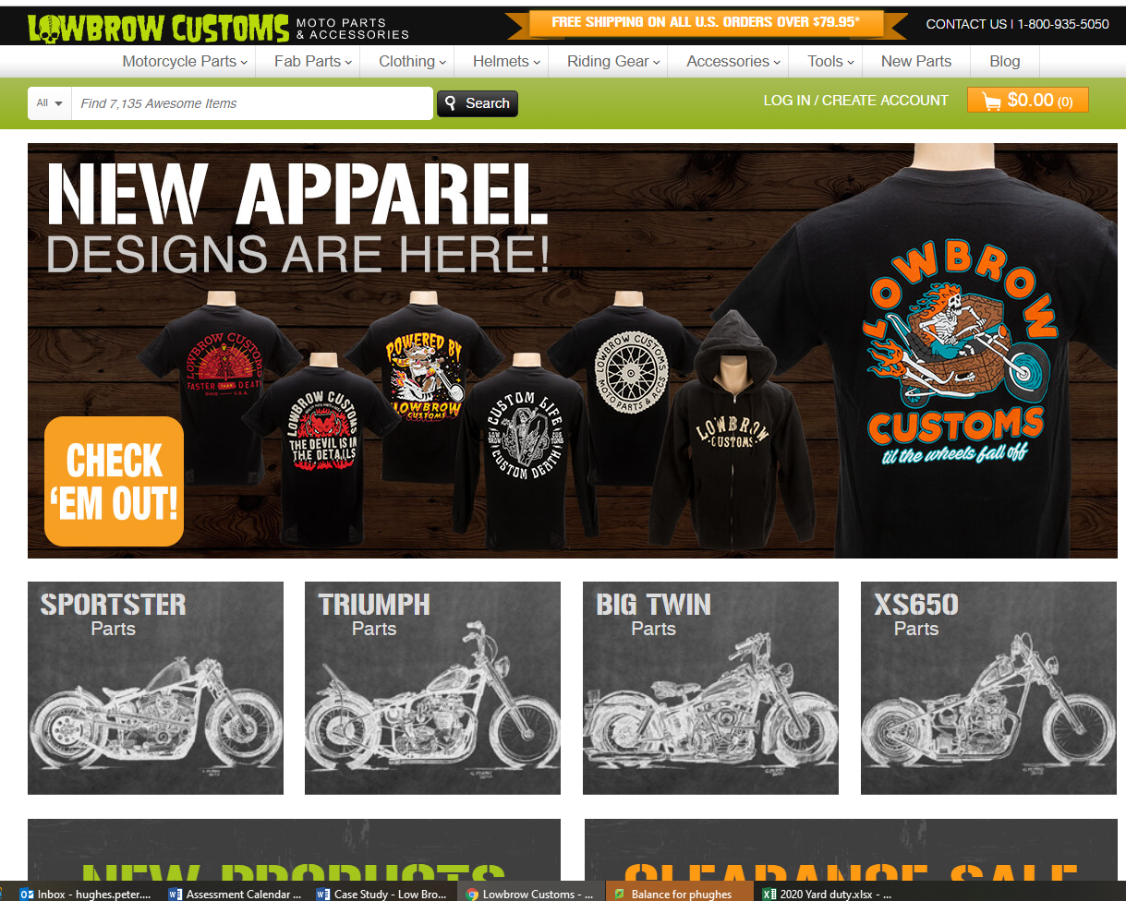
The Website
The Customer. Laurie (from Robinvale) has over 10 historic Triumph motorcycles and restores them himself. Why is he so excited about buying parts from Low Brow Customs?
____________________________________________________________________________________________________________________________________________________________________________________________________________
