BSBWHS201A Contribute to health and safety of self and others
ASSESSMENT TASK 2017 ROBINVALE COLLEGE
----------------------------------------------------------------------------------------------------------------
In a Microsoft Word document, present a report on the following questions using Information, Communications and Technology (ICT). Your report can include words, graphics and images that you can find online. The focus of this task is from Victorian Legislation (Occupational Health and Safety)
You may be asked about an industry you know or have done work experience in. Use that industry to answer the relevant questions. If you cannot decide on an industry, use one of the following as an example:
Trade (electrical, plumbing, construction, tiling, and bricklaying)
Equinine or veterinary science.
Food
Earthmoving, mining, oil drilling.
Retail
Beauty and hairdressing
Primary production
----------------------------------------------------------------------------------------------------------------

1. Work Safely.
1.1 Identify a safety procedure and instructions that would be used in the industry you know. Outline how that safety procedure and instructions would be used.
Example: (Mr P Hughes explains how to keep all 10 fingers in the mining industry)
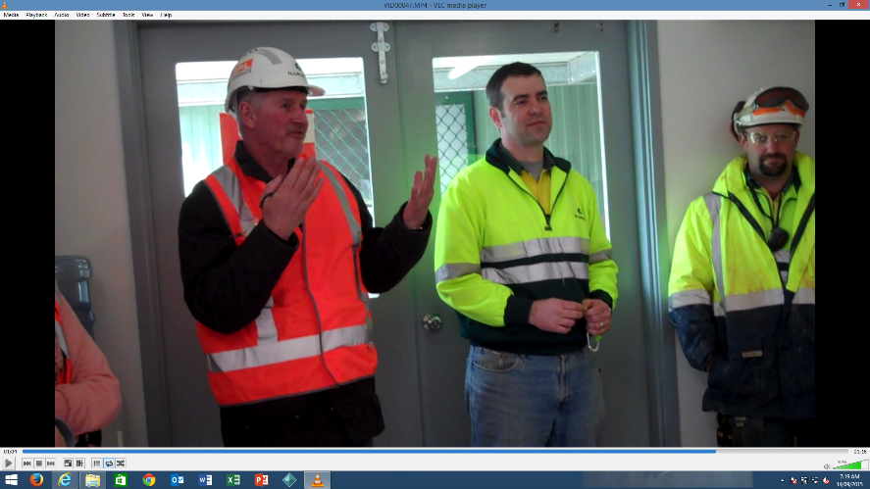
In the mining industry, safety is very important because an accident can cause a serious injury. Workers are required to wear Personal Protective Equipment before they can enter the work site.
It may consist of high visibility vest, hard hat, safety glasses, steel cap boots and gloves.

1.2 Examine a piece of equipment in your industry that has a pre-start safety check. Outline the procedure required before the equipment can be put into use. Sometimes it is as simple as checking that the Test and Tag is up to date. In other situations, it may require you to fill out a safety form or Job Safety Analysis (JSA) worksheet.
Example
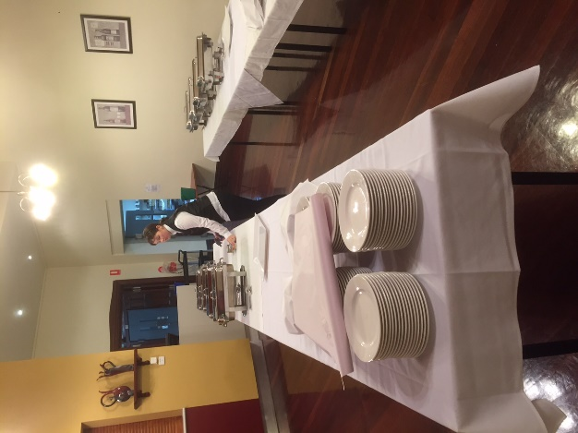
Year 12 student Bernadette prepares for the celebration day breakfast. In food technology, a lot of equipment is used. Bernadette also has to look at how the room is arranged for the busy event that is about to follow.

Dangers here are burning from hot surfaces.

1.3 What is a possible emergency incident that can happen in your workplace? What are the workplace procedures for responding to that emergency incident?
(example, fire in a building)

1.3 In recent years the Commonwealth Government operated a home insulation scheme. The scheme was designed to help Australian residents save electricity and gas in their homes. A subsidy was provided for the installation of insulation in homes.
The subsidy and scheme created a lot of employment for people in Australia. Several people were injured installing insulation and 4 people died.
How did the insulation installers die?
Were they following safety procedures when the accidents happened?
What has been the outcome of the deaths of these workers in regard to safety procedures in that industry today? (3 sentences)

2. Implement work safety requirements.
2.1 Attached an image of the staff and management representatives for OH&S at Robinvale College.
2.1 List the hazards in the following images of a workplace. The procedure for reporting them is to describe the hazard and possible risk associated with it.

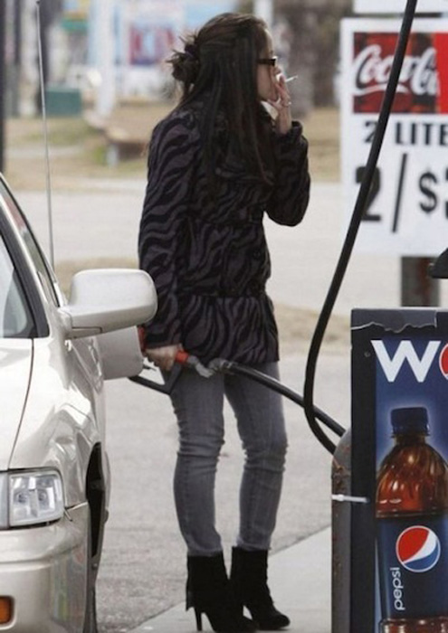
Describe the Hazard

What is the risk associated with the hazard?

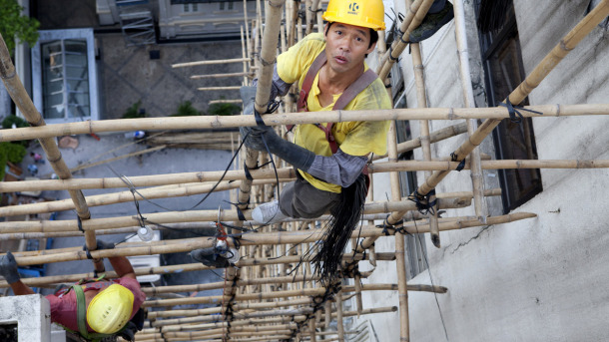
Describe the Hazard

What is the risk associated with the hazard?


Describe the Hazard

What is the risk associated with the hazard?

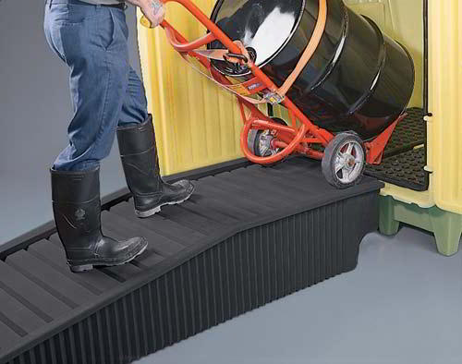
Describe the Hazard

What is the risk associated with the hazard?

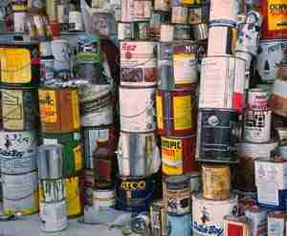
Describe the Hazard

What is the risk associated with the hazard?


Describe the Hazard

What is the risk associated with the hazard?

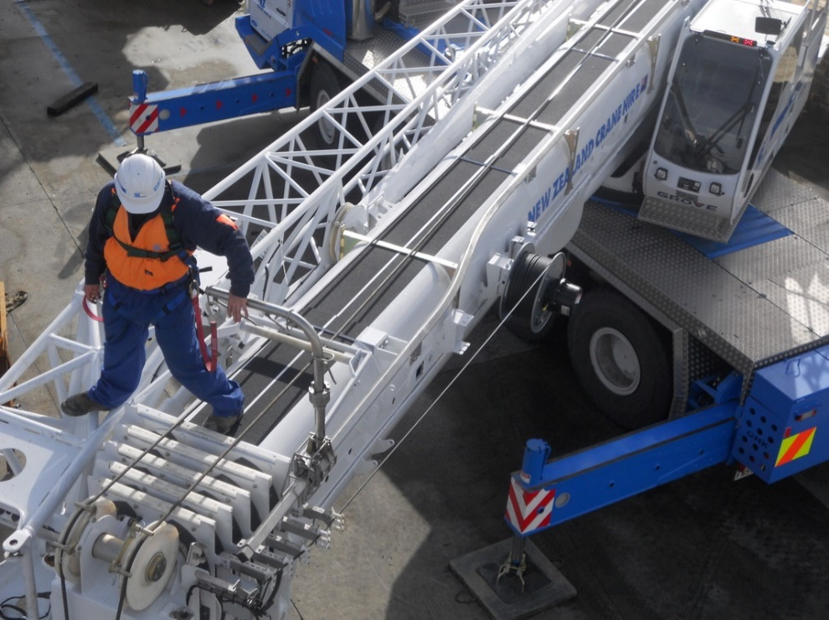
Describe the Hazard

What is the risk associated with the hazard?


Describe the Hazard

What is the risk associated with the hazard?

2.3 Locate a Workplace Health and Safety policy or procedure for your workplace (note it may include work instructions). Paste it in your report.
Example: OH & S Legislation in Victoria for the construction industry – working in extreme temperatures – this is a link to guidelines for assessing risk.
http://workplaceohs.com.au/hazards/work-environment/extreme-temperatures

2.4 What is the procedure for reporting workplace accidents in your workplace?
What would you do if an ambulance is needed and you are the only person on the jobsite?

You have been driving your work vehicle to a job site. On the way to the job an elderly driver crashes into you on the corner of McDonalds Road and Plenty Road. Nobody is injured but the work vehicle is damaged and expensive equipment is also damaged. Your vehicle needs to be towed.
Fill out the following accident / Incident form.
Your Name
Date (today)
Date of Accident / Incident | 22/1/2017
Location of Accident / Incident
In your own words describe what happened
List any damage to property or persons.

2.5 Already completed.

3. Participate in Workplace Health and Safety Consultative Process
3.1 What is a toolbox meeting?
Why are these types of meetings useful in trades and jobs where there is a high degree of risk?
3.2 Are toolbox meetings a useful way to raise or find safety issues in a workplace?
3.3 access
http://www.worksafe.vic.gov.au/safety-and-prevention/workplace-inspections/do-your-own-inspection
Briefly summarise the 3 main steps in ‘Do Your Own Inspection’.

For your industry or an industry specified at the beginning of the Report, design a one page toolbox meeting template that could be used in that industry.

Additional Requirements
Asbestos Handling.
Describe what asbestos is and where it is likely to be found.
How should asbestos ben handled and who should be called in to handle it?
From the Yellow Pages, find a licenced asbestos remover in your area and list it here.

White Card (Safety Induction Card)
What is a White Card?
Who is required to do the OH & S induction necessary to receive the card?
Do you have a White Card?

Your Industry.
Research your industry. The Worksafe Website may contain some of the information.
What are the most dangerous aspects of it?
What are the most common accidents that occur in that industry?
What is required to make that industry safer?

General Safety
First Aid Kits. Find a good first aid kit online that could be carried in your own personal motor vehicle.
Present that kit in your report and list its price and contents.
Why did you choose that kit?
Why would it be a good idea to carry a decent first aid kit in your own motor vehicle?

Final Things.
Hazards can include anything that can cause harm. Present a guide (one page) to identifying and removing one of the following hazards of your choice.
Fatigue
Hazardous equipment
Hazardous work practices
Intoxication
Needle sticks
Sources of infection
Stress
Unsafe work practices
Example:
http://www.abc.net.au/news/2015-07-20/concern-over-escalating-use-of-ice-in-mining-industry/6632586

