LOYOLA COLLEGE 2015 (Cert II in Small Business Operations / Innovation)
VU21422 Undertake Basic Market Research and Promotion for a Small Business Product or Service
Assessment Task – Mr Peter F Hughes Time allotted - 6 weeks
--------------------------------------------------------------------------------------------------------------
Overview of the Assessment Task.
In this Assessment Task you will be focusing on conducting marketing research, developing a marketing strategy and making a marketing plan. The emphasis is on small business and the choice of business will be directly related to your work placement.
The geographical area for the research and placement of your marketing plan will be inside the area marked on the Google Map below. This is an established market and includes the fast growing area of the City of Whittlesea. Your market also includes the area of Kinglake that is being rebuilt after the fires of Black Saturday.

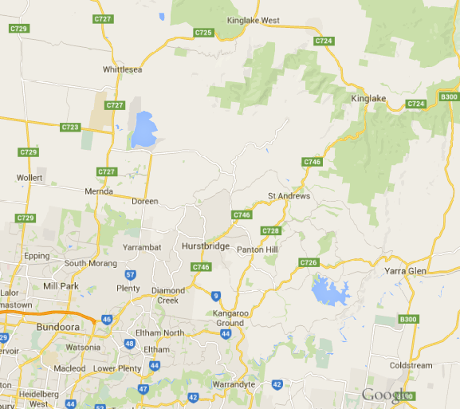

Your research work may be conducted in groups of 2 however each student is required to submit this assessment task individually.

Background
Assume you have now qualified in your trade or vocation. You have been successfully working for an employer for several years and now wish to work for yourself and establish your own small business (after all you did spend 2 years studying for your Cert II in Small Business Operations / Innovation).
You are fortunate in that you live in one of the fastest growing areas of Australia. Being young and energetic, now is the time to establish your own business and reap the rewards of all that hard training and studying.
Choose a suburb on the Google Map as your base area of operations. Decide how many employees you will need to operate your business in the first few years. Will you have a shop front, a warehouse or an industrial space? Will you need a commercial vehicle or vehicles, minibus or sedan?
The Commonwealth Development Bank has looked at your proposal and agreed to lend you $180,000 on a 10 year loan. They are now waiting for your Marketing Plan and Marketing Strategy before they release your funds.

Report – Market Research and Promotion
In a word document outline all of the information you will find that relates to the questions asked. Include any statistics, images, maps or other relevant material to answer the questions and provide an overview of the market and its ability to support your small business proposition. Include a cover page with your name and the unit number and description. Use the headings in bold in your report to break up each section.

Section One – Situation Analysis
1. Outline what products and or services your business will provide to the market. Be specific and include all hourly rates for labour and any set up costs involved. This should be at least one page, well laid out and be a good overview of what the small business is all about.
2. Describe which area of the business you expect to be the most profitable. Why do you think this is the biggest money earner for you?

3. Primary and Secondary Market Research.
Refer to page 152 of your text.
Primary research is conducted by you through surveys and questionnaires.
Design a small questionnaire that will be handed to customers after they have used your products or services. Include this in your report.

Secondary research is information that has already been gathered by other sources eg Australian Bureau of Statistics, Roy Morgan etc
(a) Conduct secondary research into the number of competitors you have in your chosen area and the products and services they offer. In this section of the report outline the results of your findings.
(b) Conduct secondary research into the type of customers you will expect to have in your area. Note, we looked at demographics last year in our TV Arial business as we profiled areas. See http://profile.id.com.au/
eg: Your business’ area and customer’s age, income, employment type etc
---------------------------------------------------------------------------------------------------------------

Section Two – The Marketing Strategy Text pages 192-193
1. Marketing Tactics. What will these be in the first 3 years of your business operation?
eg outline how you will let the public in your targeted area know about your business. An example could be as follows for Kev’s Electrical at Greensborough.
Website with contact form for quotes and bookings. Advert in local Leader Newspaper. 4 flyers delivered in the area each year. Fridge magnets. Logos on the van and at the Industrial Workshop located in Greensborough. Uniforms with logos.

2. Business Goals.
The Marketing strategy is to cover 3 years of operation. The bank needs to know how you plan to expand your small business in order to be successful over that time.
Describe how you plan to increase awareness of your products / services apart from your set advertising.
Describe how you can sell more products from a certain supplier and possibly gain discounts / rewards from that supplier.
Outline how you would plan to reach a new customer segment over that 3 year period.

3. Profile your Potential Customer.
You have done a lot of research on your market and the people that live in that targeted area. Now it is time to show the bank just exactly what your typical customer would be like and what their needs would be.
Outline this typical customer from your research by showing what their buying patterns are, how they buy, where they buy and what they buy.
eg Kelly’s Mobile PA and Music Hire business in Thomastown might profile their typical customer as:
‘Our typical customer is a corporate organisation looking to add something to their event be it a wedding or party. They normally use our business 3 – 4 times a year and they are located in the Northern suburbs of Melbourne. They pay with Mastercard on a 30 day account normally through an online invoice. Sometimes they recommend us to their other clients. Every so often they will use us as well as another hire firm for a major event like a music festival.’

4. Profile 2 of your competitors in your area.
This is an advantage in knowing who your competitors are and what they do.
Identify their products, prices and their marketing tactics and include them in the report.
e.g. Davo’s Carpentry Service in Bundoora, One competitor is BHD Builders who employ 3 carpenters and concentrate on renovations like we do. They also advertise kitchen and bathroom specialists same as us. BHD says $70 per hour for a tradesperson and have online quotes like us. They have a website and also do letterbox deliveries
---------------------------------------------------------------------------------------------------------------
Section Three – The marketing Plan
You now know your potential area for operating your business. You know who lives and works there. You have a profile of a typical customer. You also have a broad outline of your competitors in the area.
It is time to build your Marketing Plan as it will be presented to the bank.
Present this as a one page document in your report.
Label it: YEAR ONE, TWO and THREE
Decide on your budget for this promotional activity of your business.
eg Bank Loan 10 Years $180,000
Marketing Allocation = $30,000 for 3 Years = $10,000 per year.

Include how you plan to use the following tools.
Social Media and which ones you plan to use.
Advertising and the types used eg Yellow pages, Newspaper Adverts, Signage
Any other marketing formats you have researched and decided to use.
----------------------------------------------------------------------------------------------------------------
Checklist
Does my report have a cover page?
Have I answered all the questions?
Is my report well presented with graphics and media?
Will the business succeed based on my plan?
----------------------------------------------------------------------------------------------------------------

