VCE LEGAL STUDIES
HOLIDAY WORKSHOP
LORNE – Great Ocean Road
Thursday October 3 2013

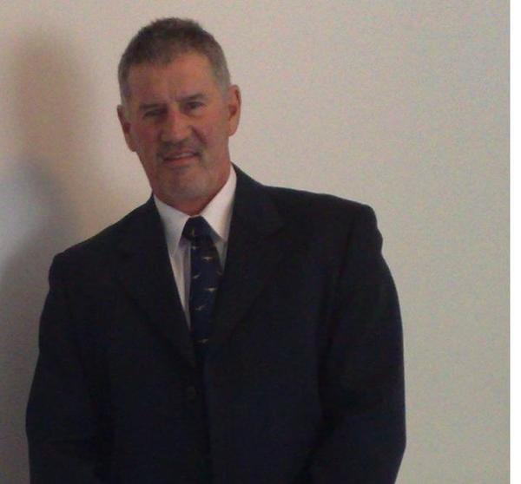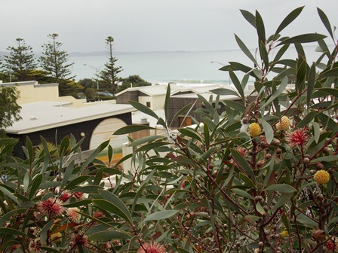

The program will comprise: 10.00am – 12.00pm Unit 3 revision and examination practice questions in a workshop environment. 1.00pm – 3.00pm: Unit 4 revision and examination practice questions.

St Cuthbert’s Uniting Church Hall
Enter via Smith Street
The format will be PowerPoint Presentations followed by practice questions working in groups and individually. This type of workshop can be very valuable to students as they commence final preparations for their examinations. The presenter, Mr Peter Hughes BCom GradCertCorpMgt GradDipEd, is a VCE Legal Studies teacher from a private Melbourne School.

LIMITED PLACES COST $30 (includes materials)
Phone 0487 238 161
Email peter@peterfrancishughes.com

